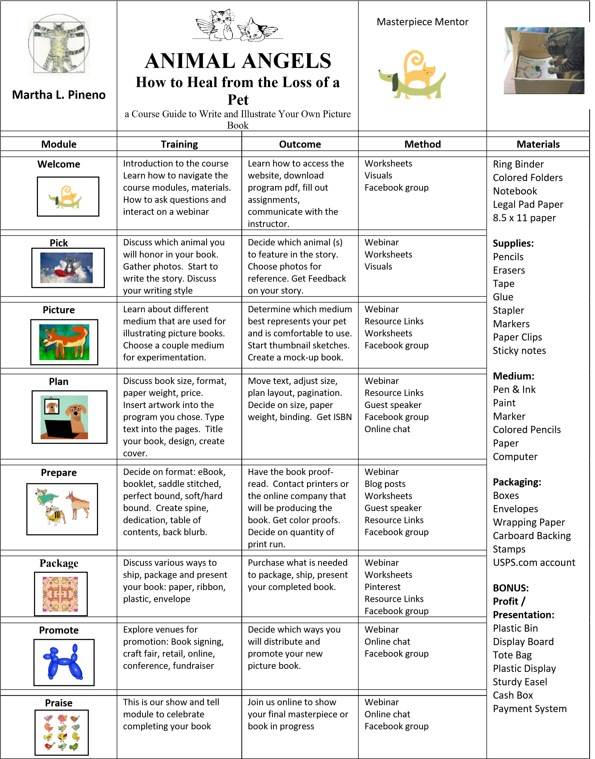
© 2020 Creative Coaching Company, Inc.

